**Invoice Management System**

**RIKZAH KHATTAL**

For my final project for TCR innovation I have developed an Invoice Management System.

**Available Features:**

* Admin Panel
* Generate Invoices
* Download Invoice (PDF)
* Export Invoice (CSV)
* TAX, VAT, Shipping Inclusion
* Total Sales Amount
* Due Amount
* Paid, Pending Bills
* Manage Invoice Records
* Product Management
* Customer Management
* System User Management

All codes and necessary files are attached as zip folder. SS of the outputs are provided below:

LOGIN PAGE

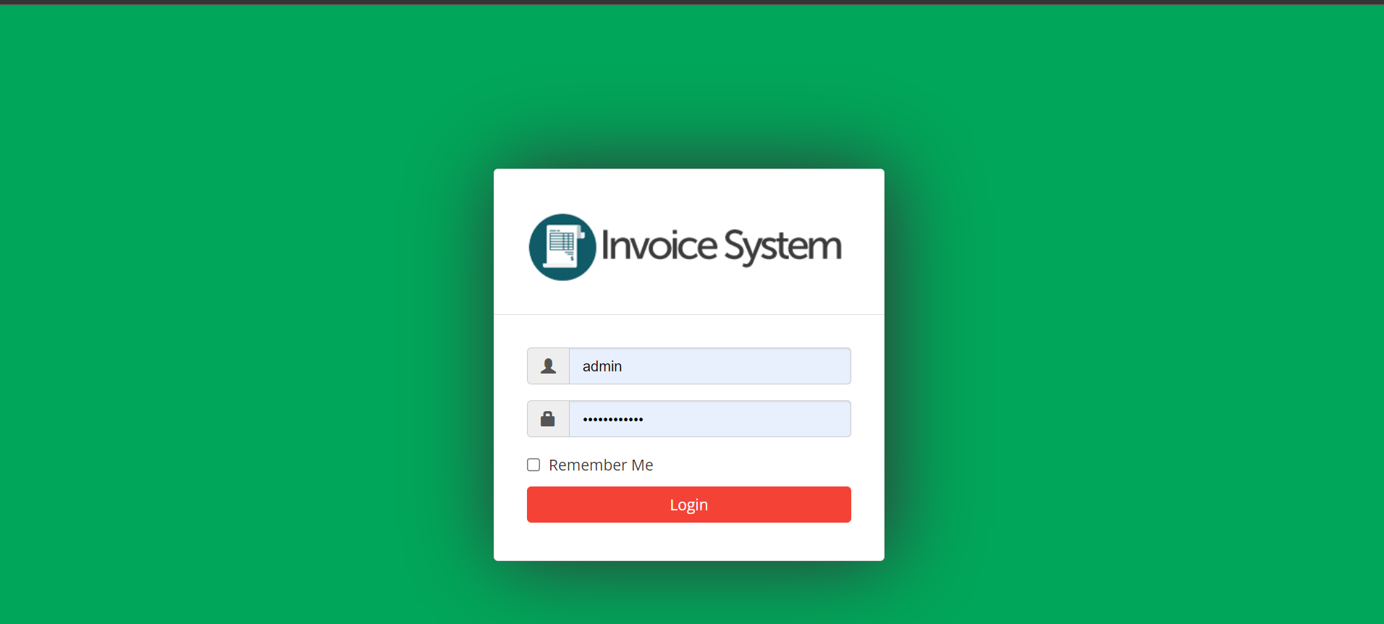

DASHBOARD

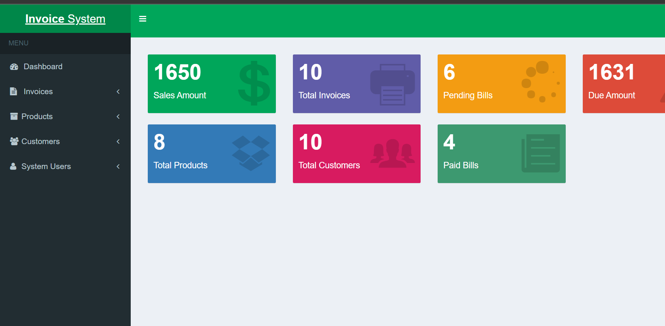

AVAILABLE FUNCTIONALITIES

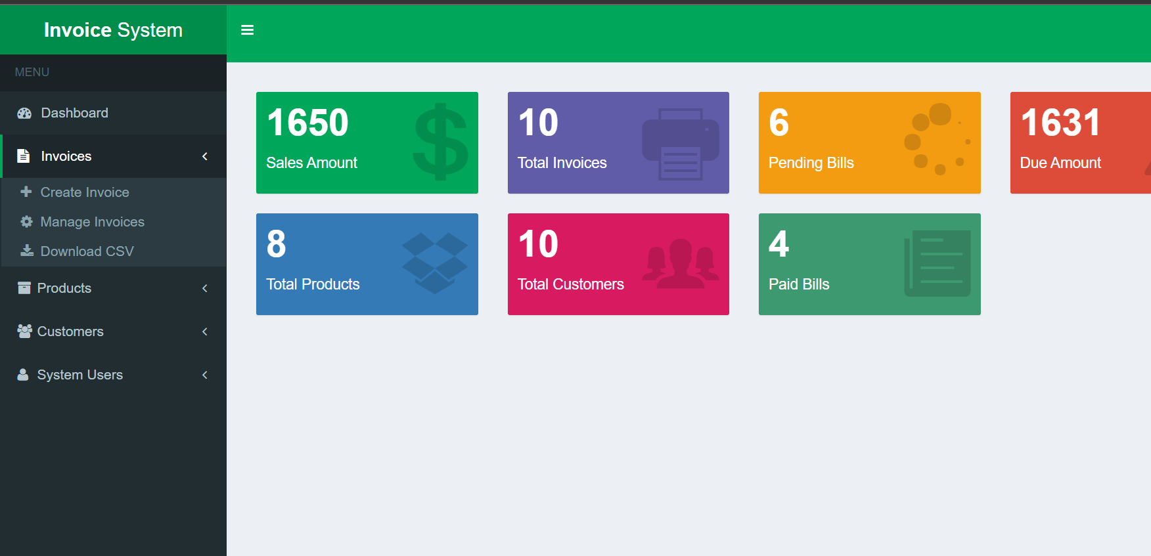

CREATE INVOICE

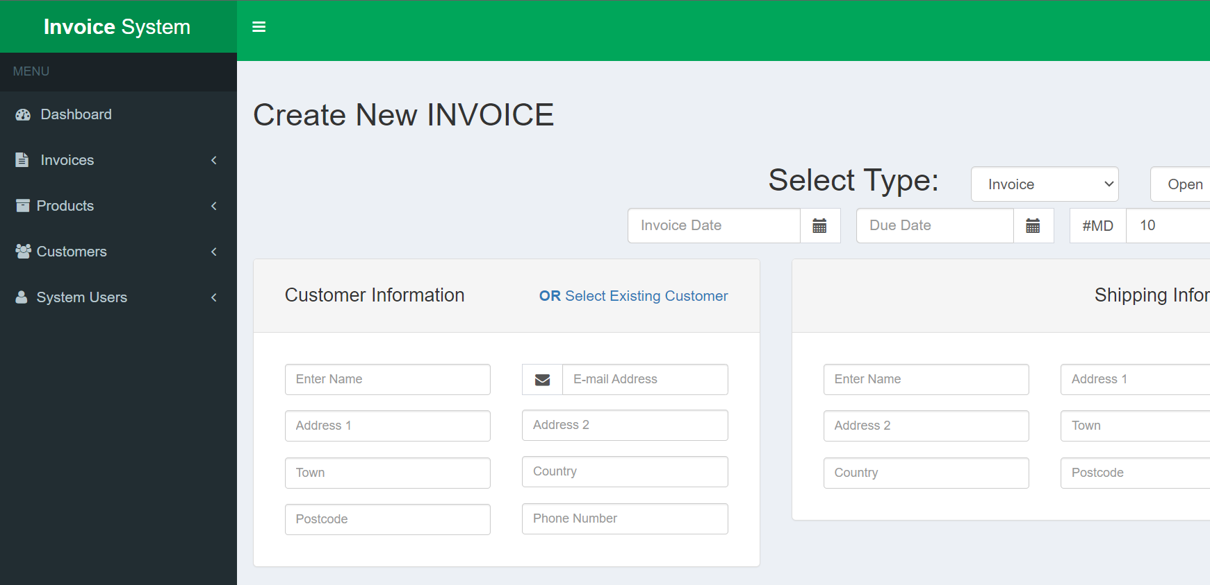

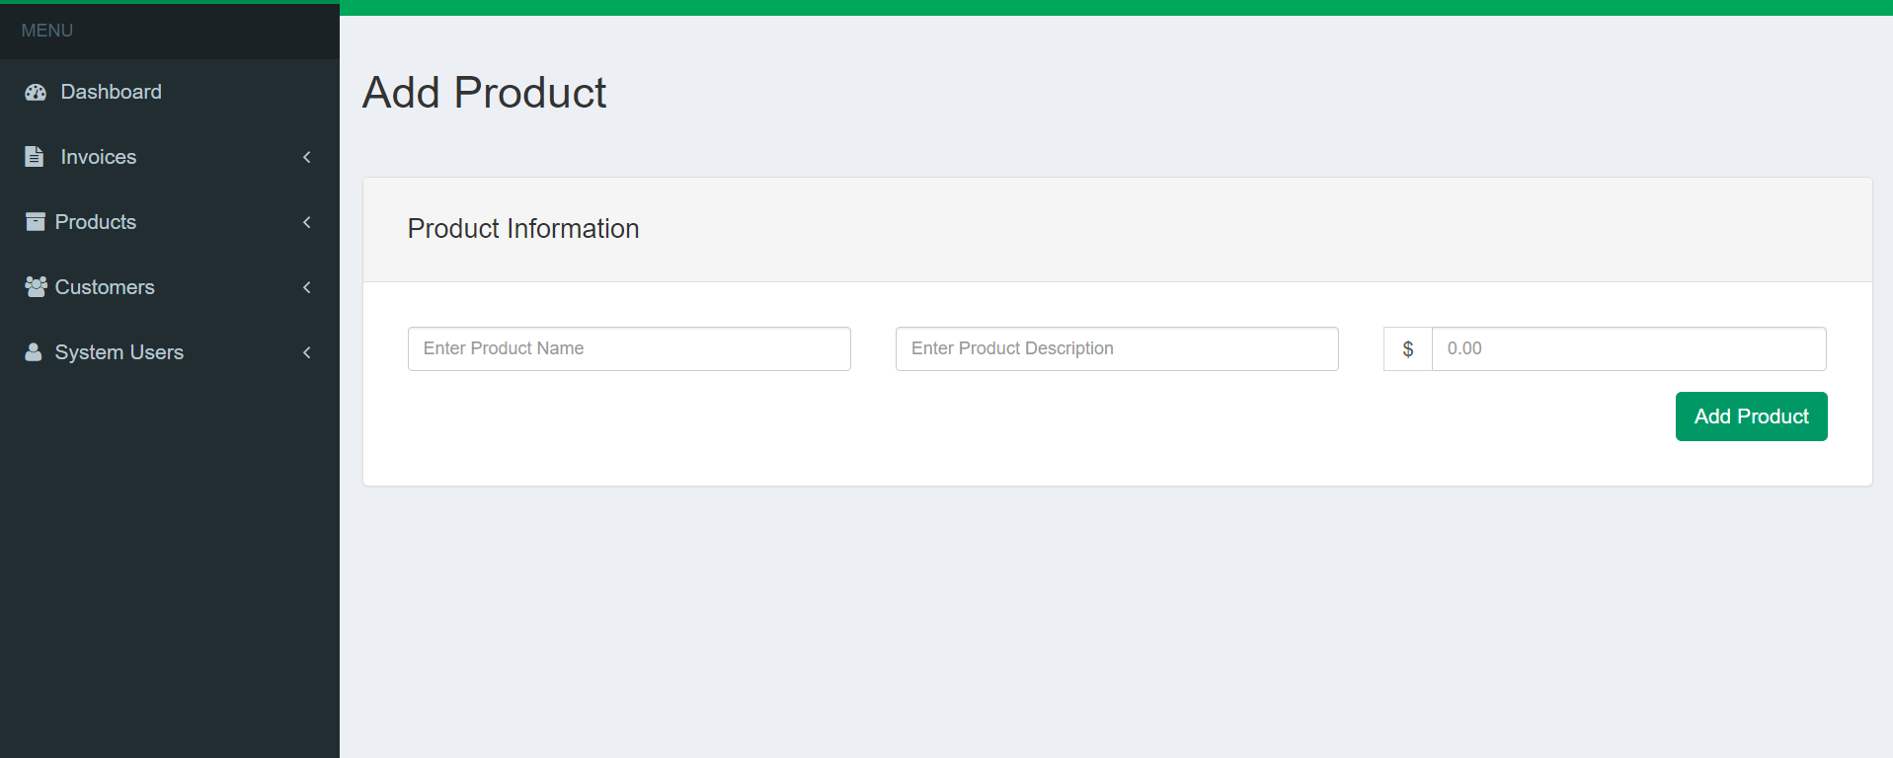ADD PRODUCT

MANAGE PRODUCT

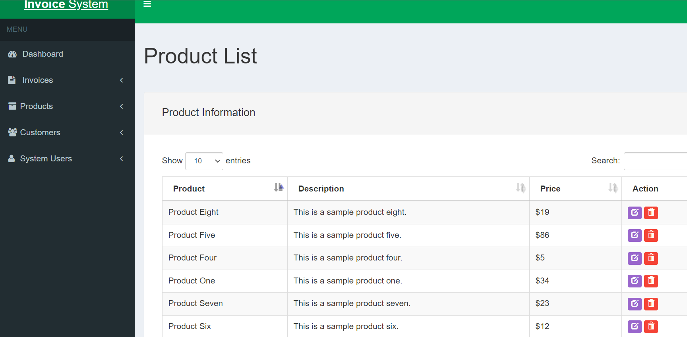

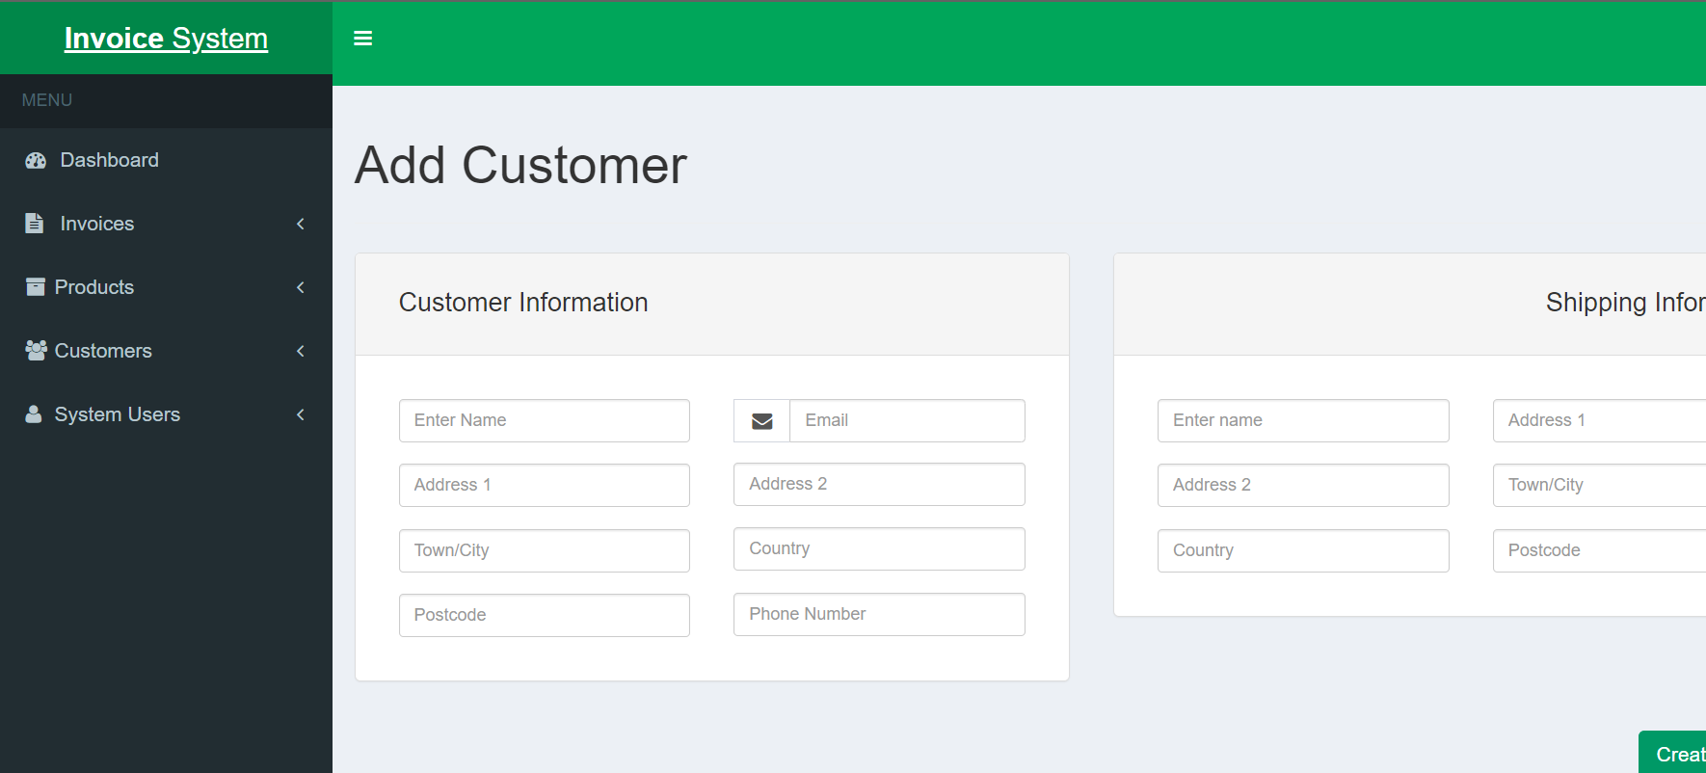ADD CUSTOMER

MANAGE CUSTOMER

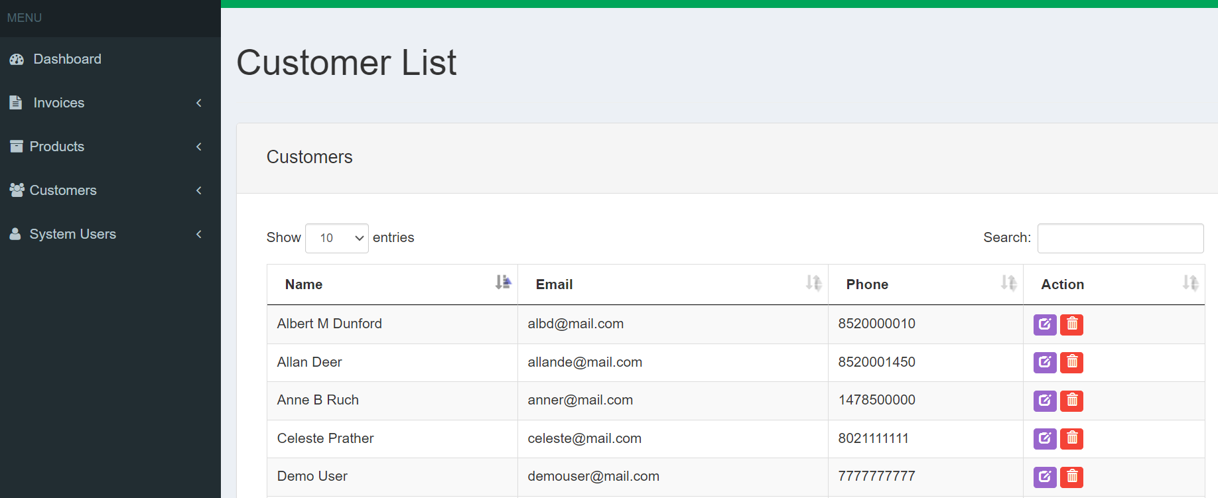

ADD SYSTEM USER

